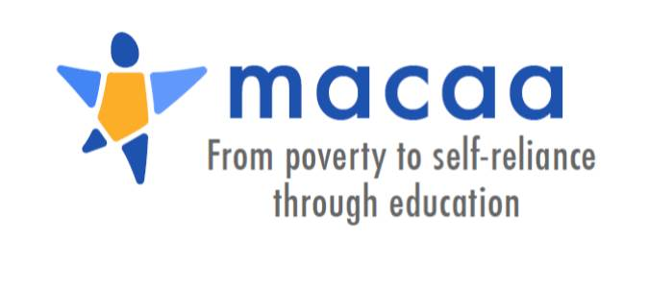

Applied Policy Project

Batten School of Leadership and Public Policy

**Project Proposal**

**About MACAA**

The Monticello Area Community Action Agency (MACAA) has been serving low-income families in the Charlottesville area since 1965. Our mission is to improve the lives of people with low income by helping them become self-reliant, thereby enhancing the economic vitality and well-being of our community. MACAA is part of the national network of Community Action Agencies, developing local solutions to poverty in communities across the country. Our service area includes the City of Charlottesville and the Counties of Albemarle, Fluvanna, Louisa, and Nelson. We operate four programs: Head Start, Hope House, Project Discovery, and Rural Outreach.

**Problem Definition**

Families with limited incomes are at heightened risk from unexpected financial emergencies. Most families have very limited personal savings and are vulnerable to a wide range of crises including sudden medical costs, automotive repair costs, home repair costs, etc. This situation applies to people with fixed incomes, such as those receiving Social Security Insurance (SSI), as well as those who are earning a paycheck but unable to save for emergencies. The current economic environment makes the problem more severe, as wage growth has not kept up with the rise in other expenses including housing and healthcare. The negative outcomes associated with a financial emergency can include eviction, utility disconnection, high-interest debt and damaged credit scores, toxic stress and trauma, and many other consequences.

**Problem Background**

Families may be especially vulnerable to financial emergencies due to current trends in social assistance programs. Welfare reform under President Clinton has led to reductions in the direct cash assistance provided to low-income households. Private nonprofits have stepped in to provide various forms of cash assistance, including through “Emergency Financial Assistance” programs that pay a rent or utility bill on a one-time basis. However, within the Community Action Network, many individual agencies have elected to shift towards self-sufficiency programs and away from direct supports. MACAA has continued to provide certain types of emergency assistance (especially rent and utility) through its Rural Outreach program. There is ongoing debate about the value of this approach. How prevalent are the negative consequences associated with financial emergencies? What is the best strategy for preventing such consequences?

**Specific Tasks**

MACAA is looking for a student-consultant to examine the scope of the problem, either nationally or within our service area, and to develop recommendations for the most effective and efficient program strategies. The project should include a review of research on the topic of emergency financial assistance and related concerns. Final recommendations could be analyzed using a “Theory of Change” approach.

**Data Availability**

MACAA can provide anonymized data on client services for the previous year. However, the student-consultant will likely need to seek out data from other sources (such as the Poverty Lab at Princeton).

**Other Concerns**

The student-consultant’s point-of-contact at MACAA will be the Senior Program Director—a graduate of the Batten School (2017).